Multiply-Questions
Key Stage 3: 2003 Paper 1 Level 3-5
1.
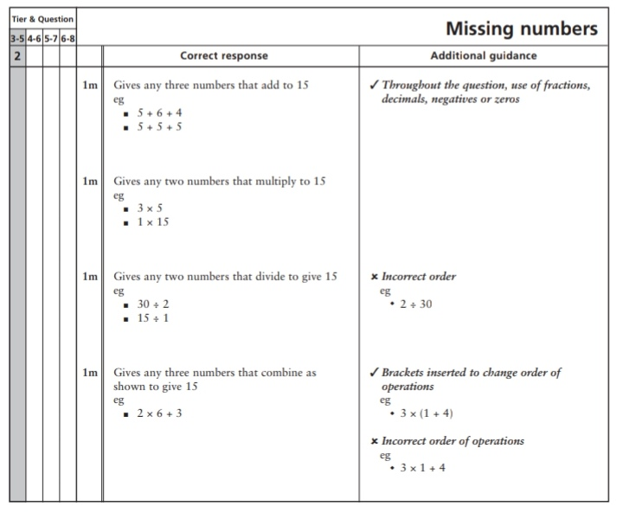

2.
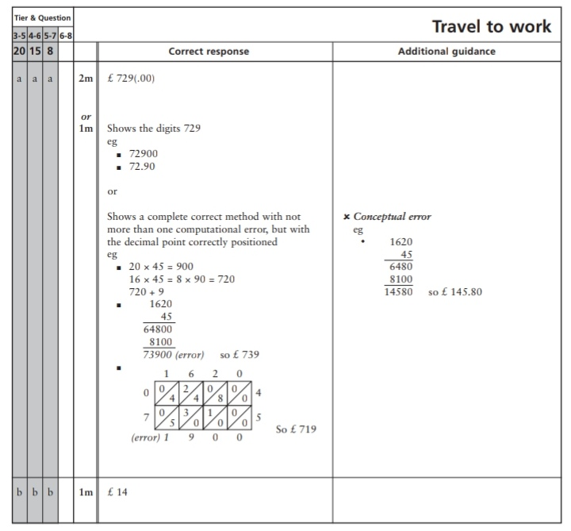
Key Stage 3: 2003 Paper 2 Level 3-5
3.
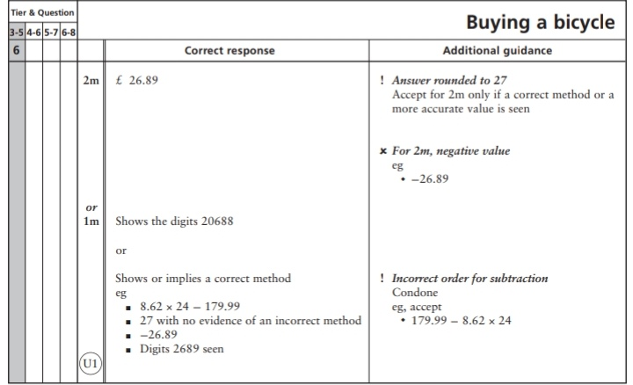
Key Stage 3: 2003 Paper 1 Level 4-6
4.
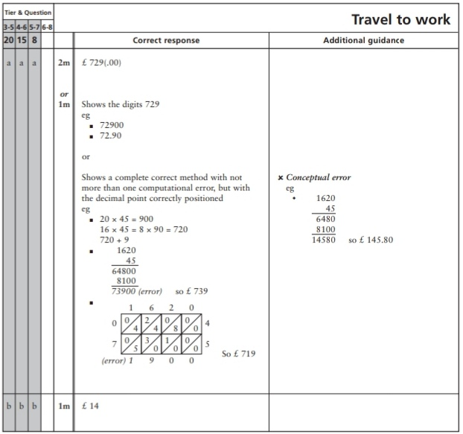
Key Stage 3: 2004 Paper 1 Level 3-5
5.
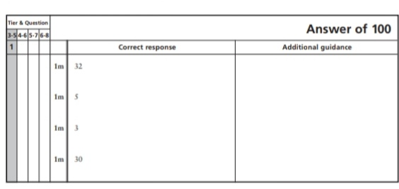
6.
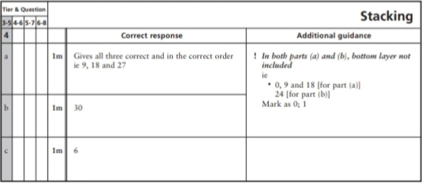
7.
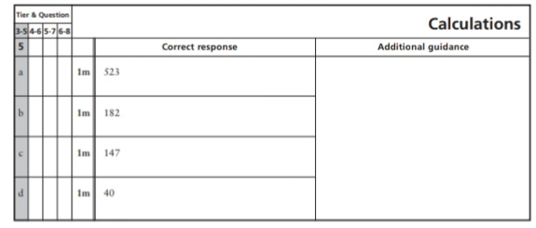
8.
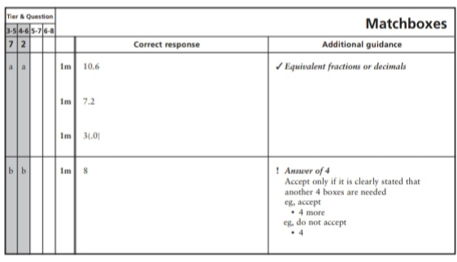
9.
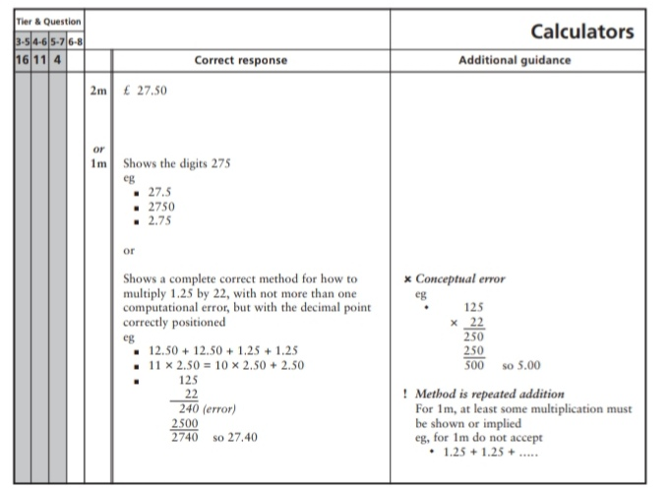
Key Stage 3: 2004 Paper 2 Level 3-5
10.
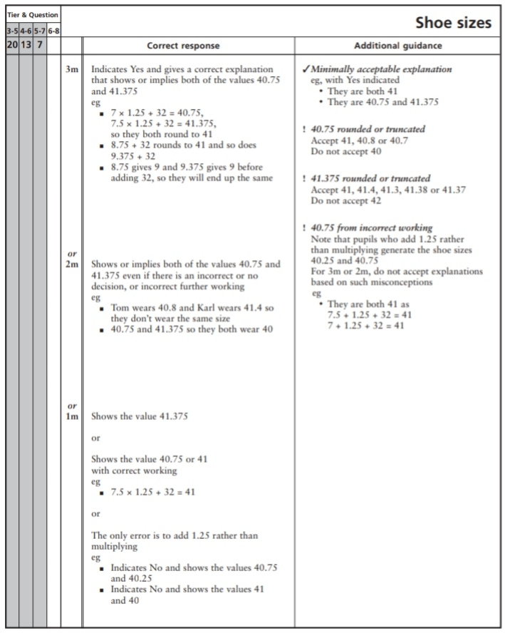
Key Stage 3: 2004 Paper 1 Level 4-6
11.
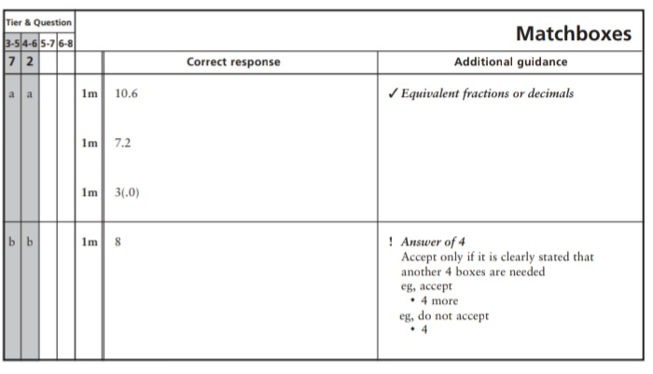
12.
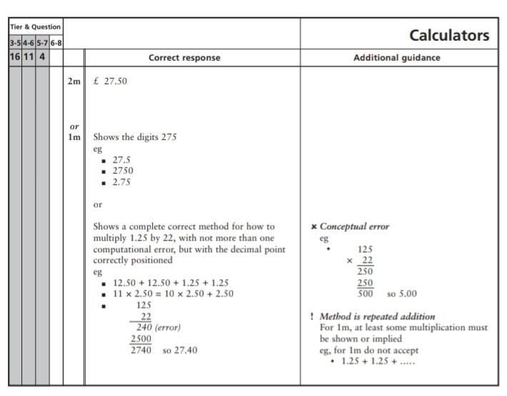
13.
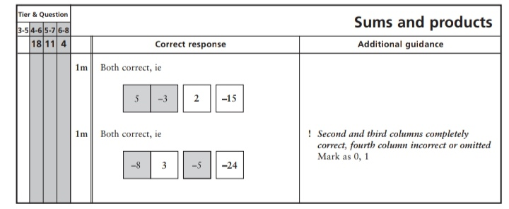
Key Stage 3: 2004 Paper 2 Level 4-6
14.
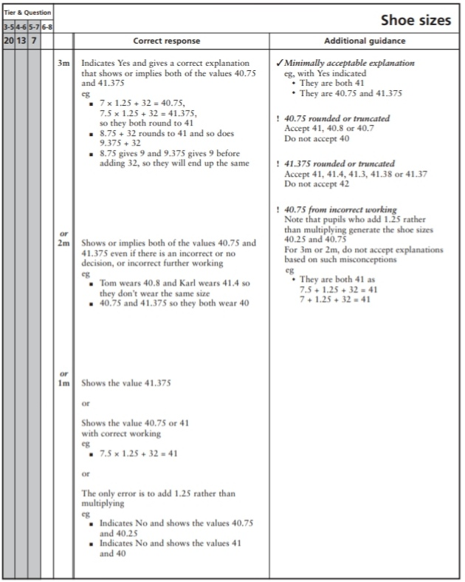
15.
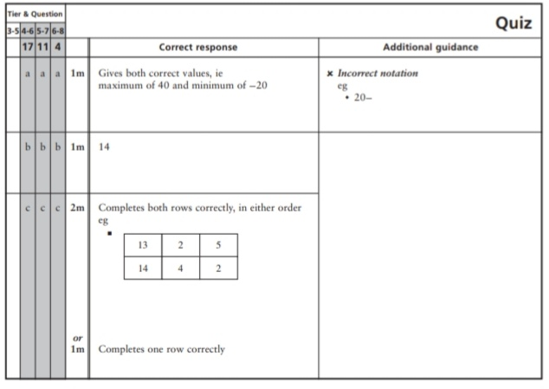
Key Stage 3: 2005 Paper 1 Level 3-5
16.
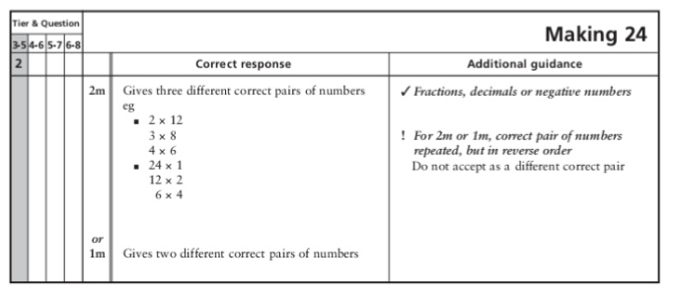
17.
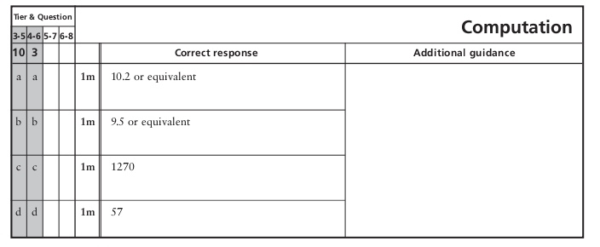
18.
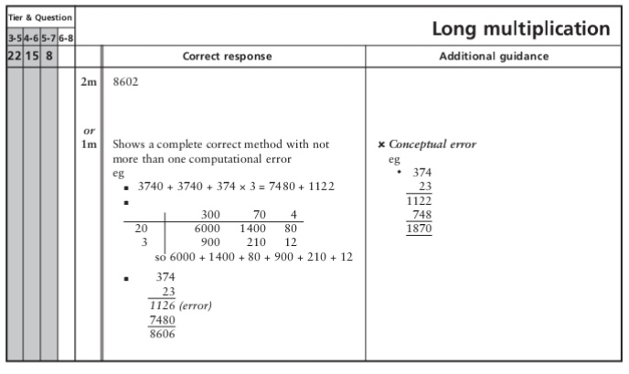
Key Stage 3: 2005 Paper 2 Level 3-5
19.
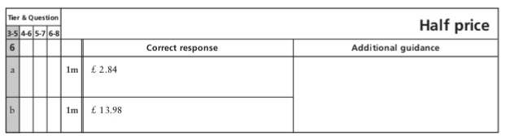
20.
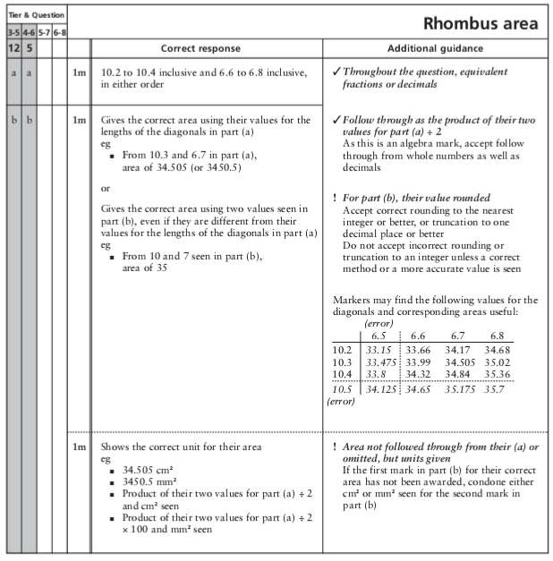
21.
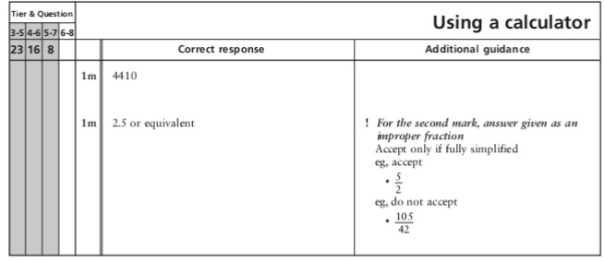
Key Stage 3: 2005 Paper 1 Level 4-6
22.
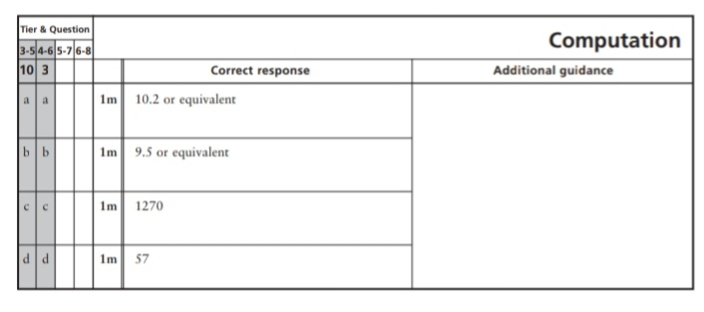
23.
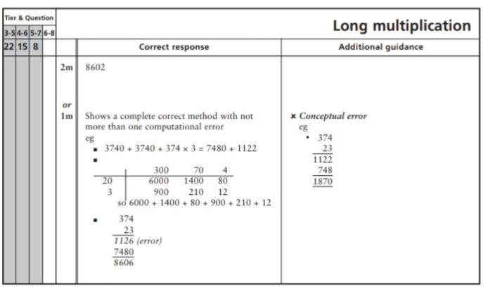
24.
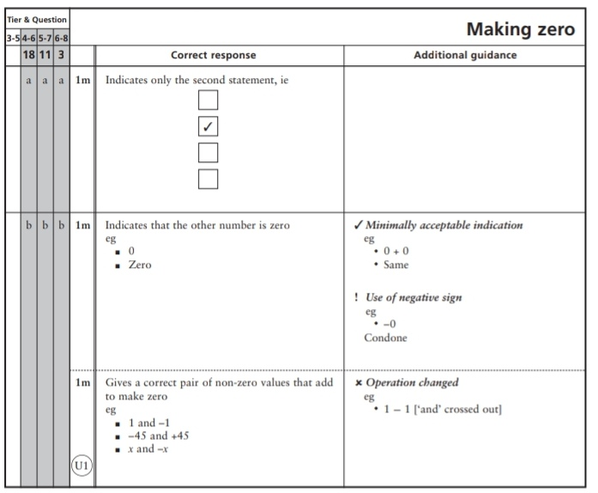
Key Stage 3: 2005 Paper 2 Level 4-6
25.
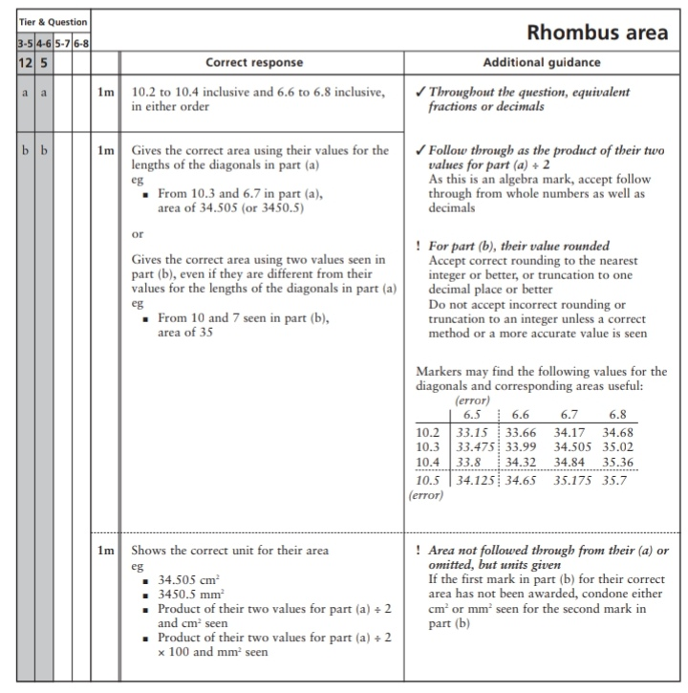
26.
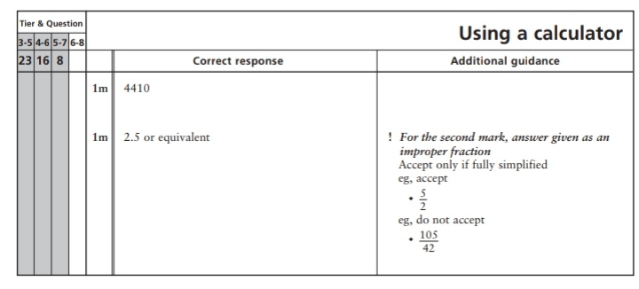
Key Stage 3: 2006 Paper 1 Level 3-5
27.
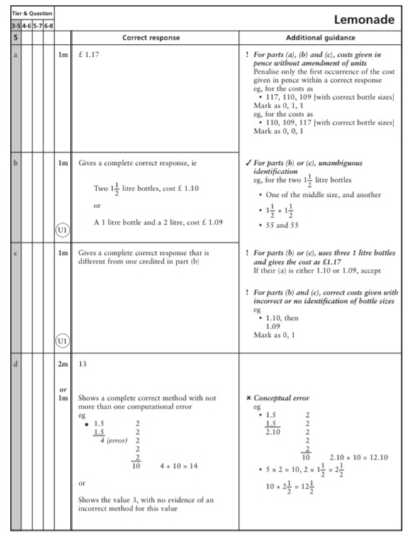
28.
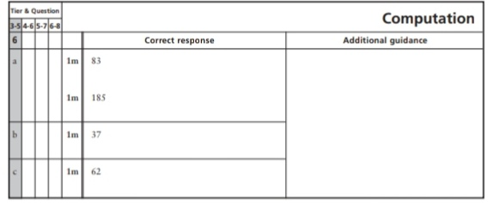
29.
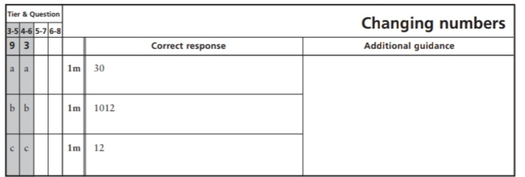
30.
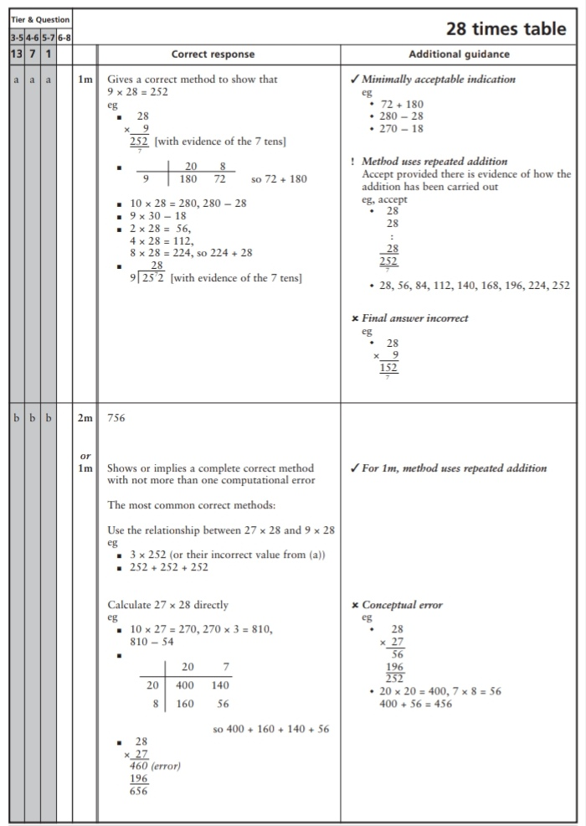
Key Stage 3: 2006 Paper 2 Level 3-5
31.
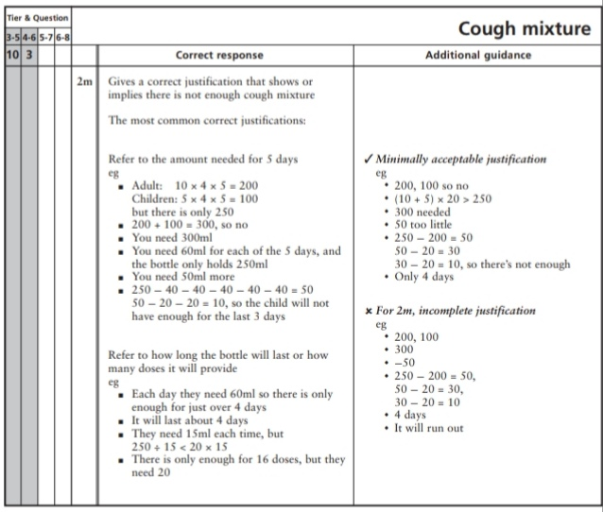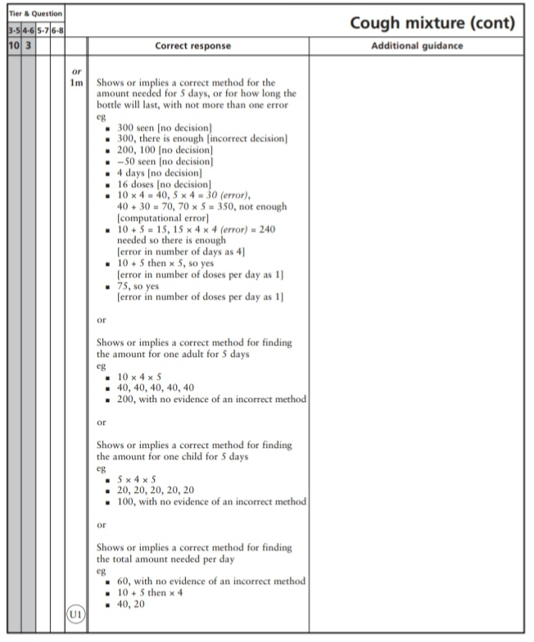
32.
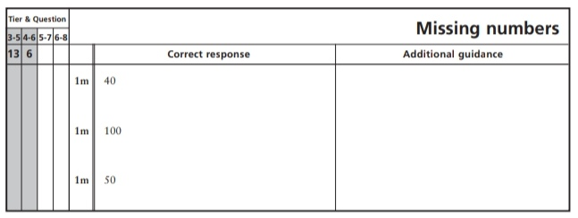
Key Stage 3: 2006 Paper 1 Level 4-6
33.
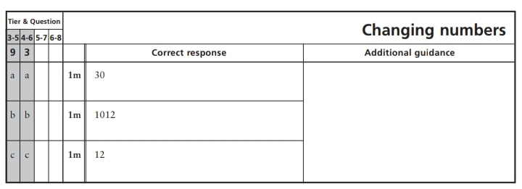
34.
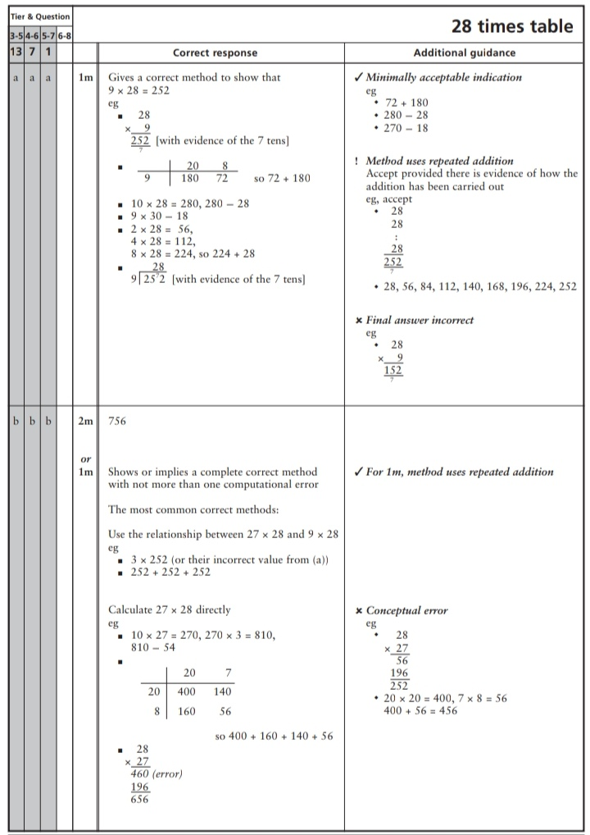
Key Stage 3: 2006 Paper 2 Level 4-6
35.
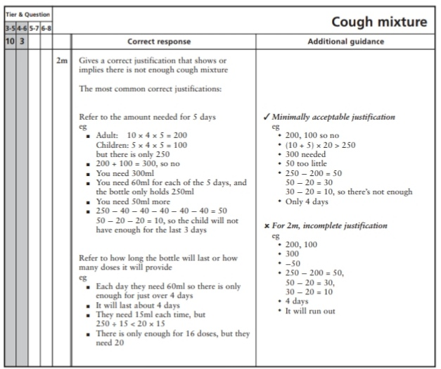
36.
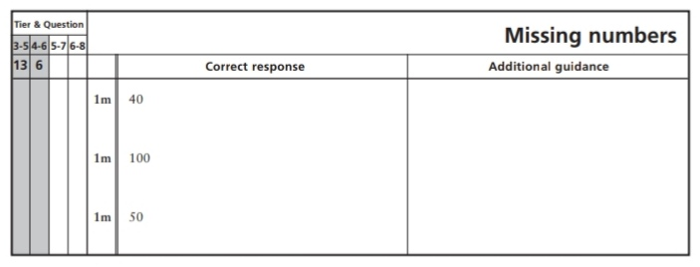
Key Stage 3: 2007 Paper 1 Level 3-5
37.
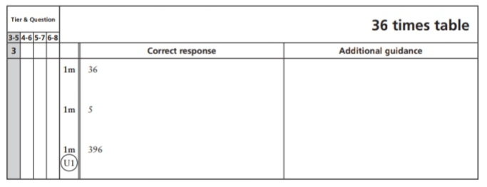
38.
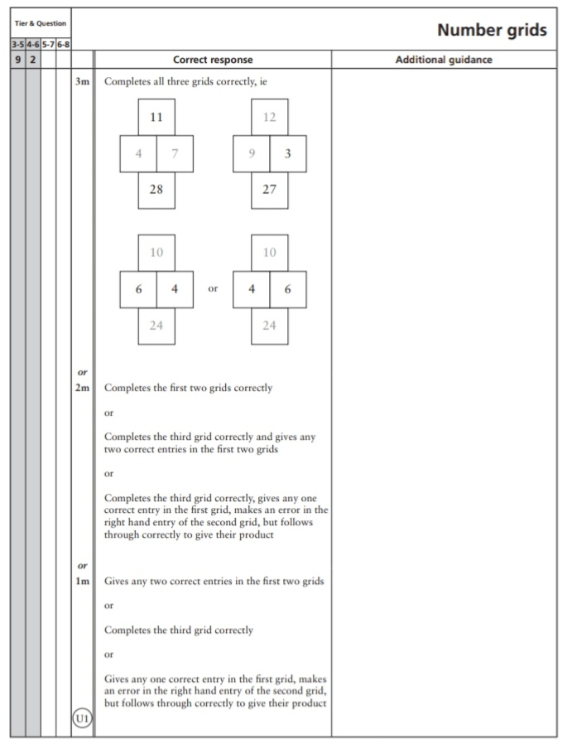
39.
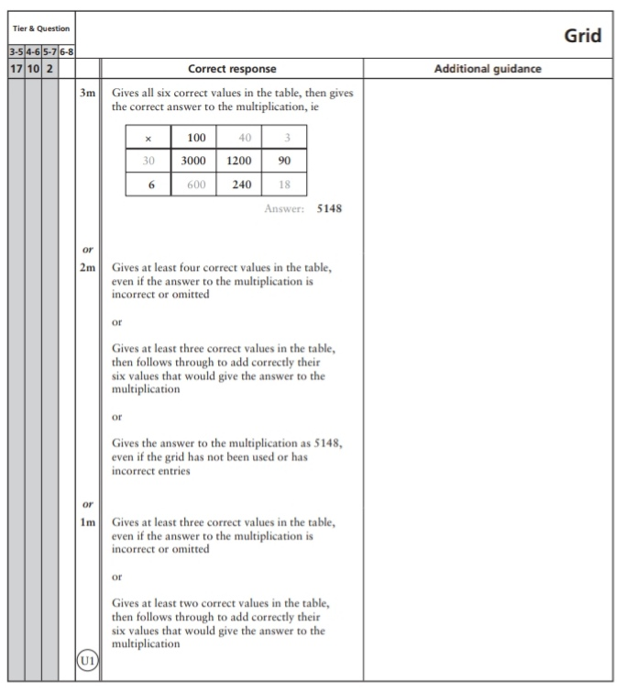
Key Stage 3: 2007 Paper 2 Level 3-5
40.
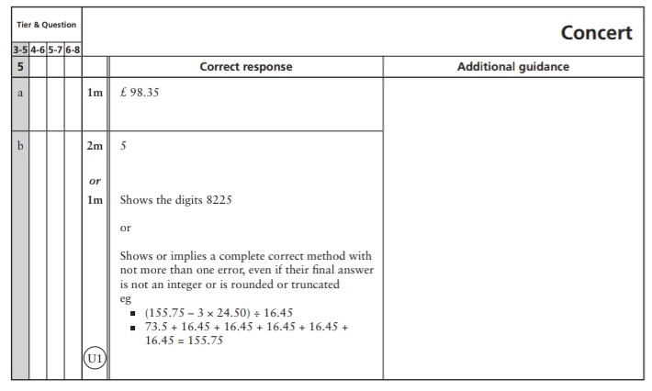
41.
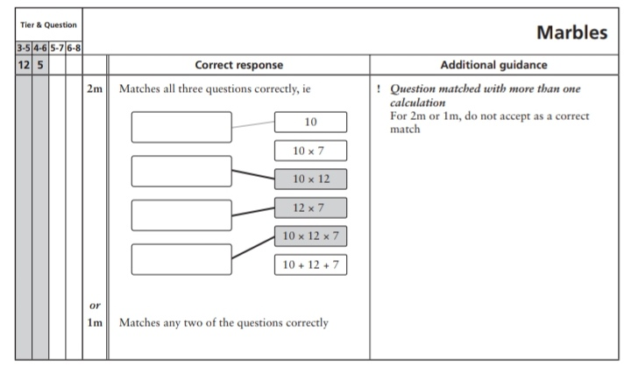
42.
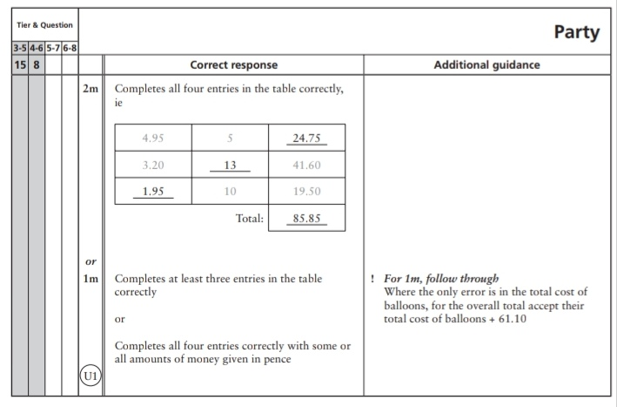
43.
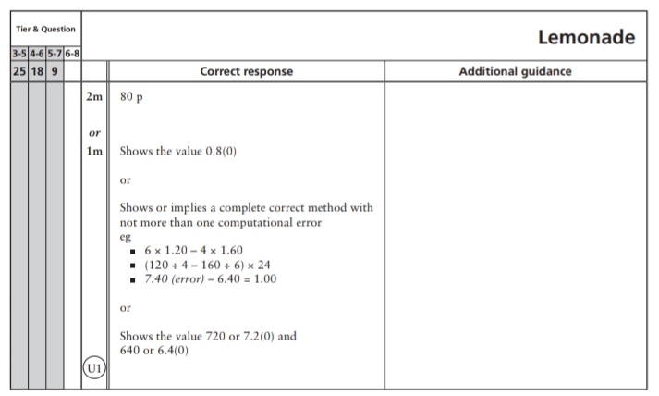
Key Stage 3: 2007 Paper 1 Level 4-6
44.
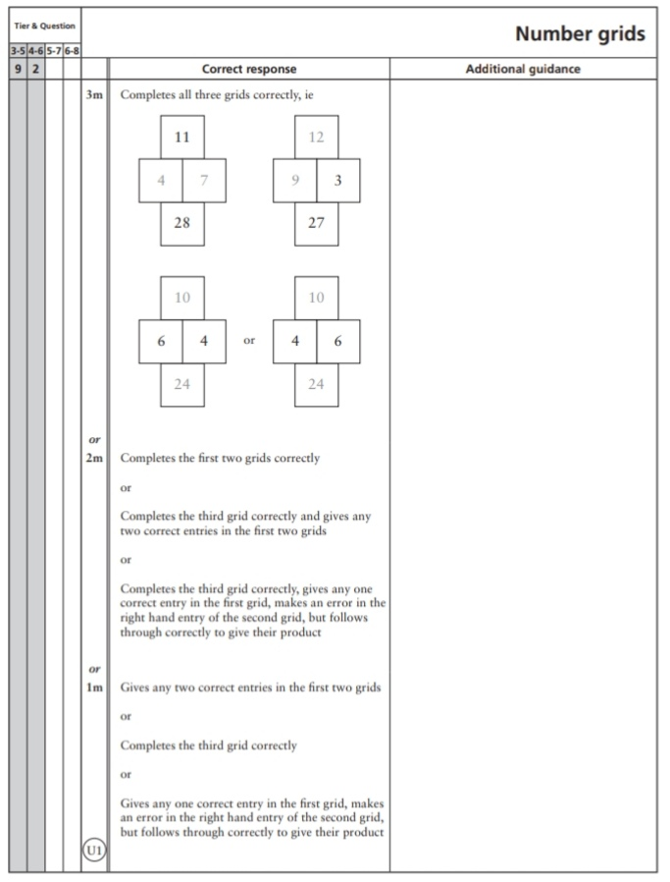
45.
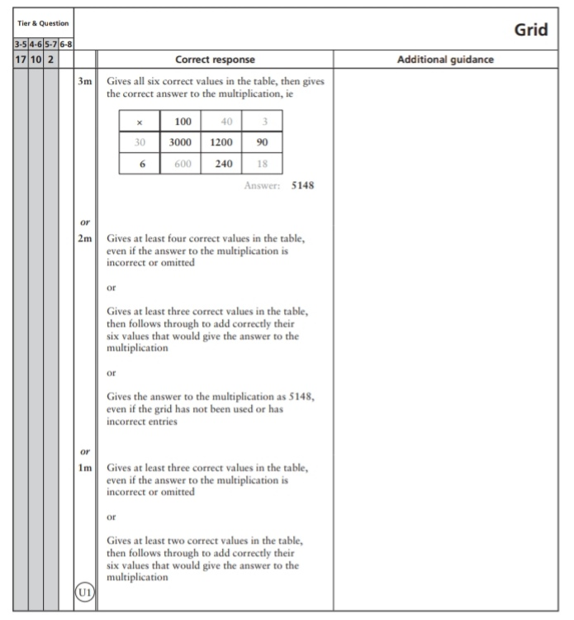
Key Stage 3: 2007 Paper 2 Level 4-6
46.
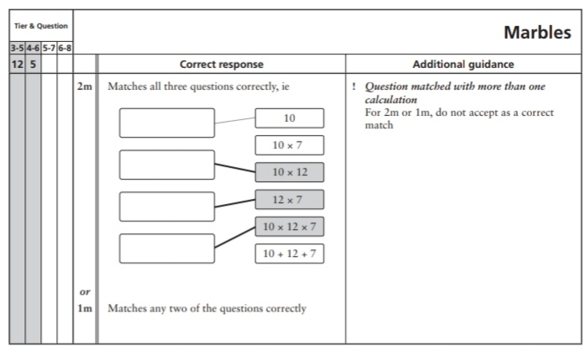
47.
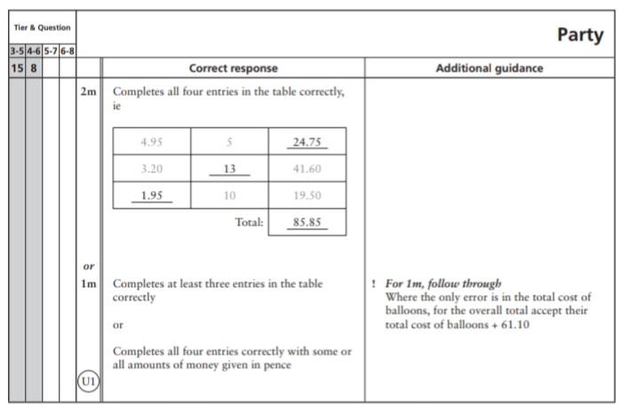
48.
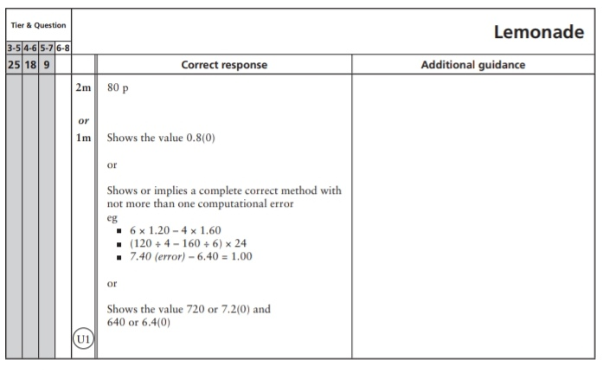
Key Stage 3: 2008 Paper 1 Level 3-5
49.
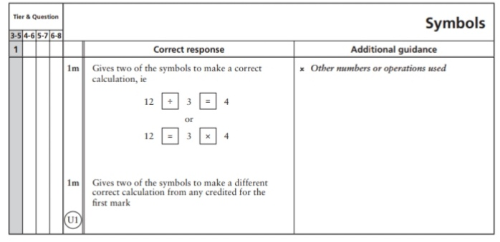
50.
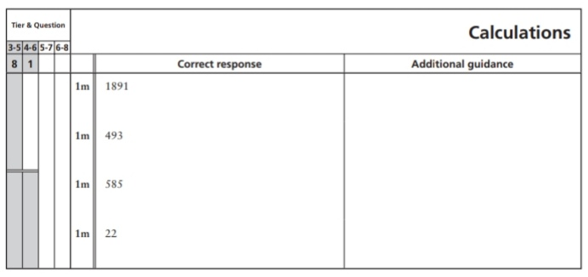
51.
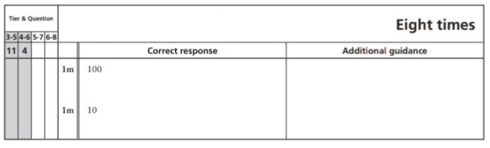
52.
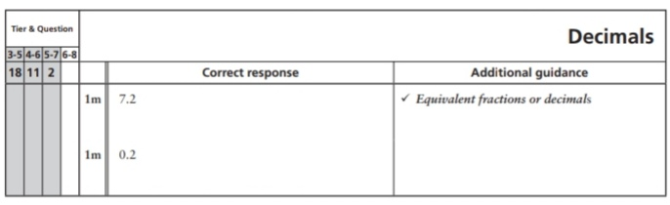
53.
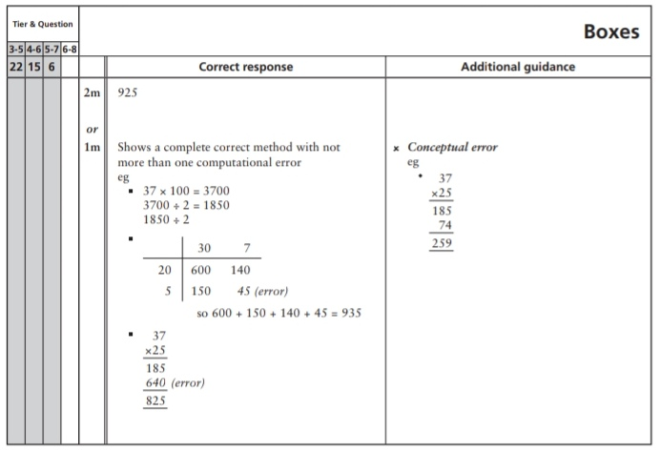
Key Stage 3: 2008 Paper 2 Level 3-5
54.
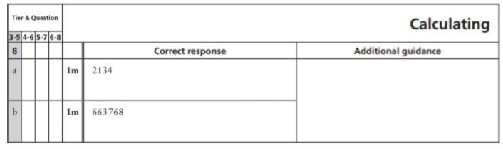
55.
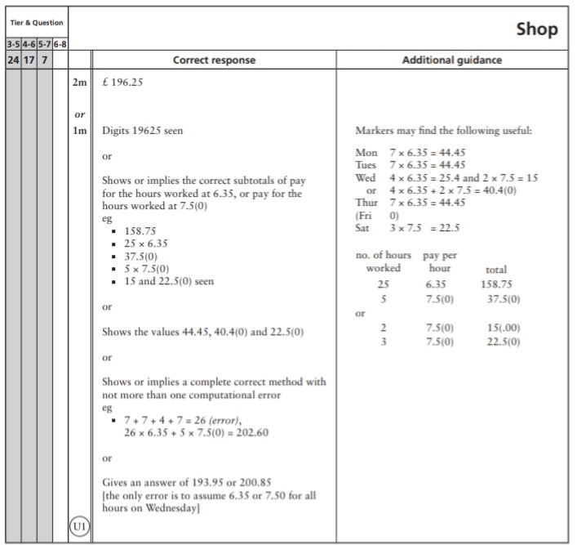
Key Stage 3: 2008 Paper 1 Level 4-6
56.
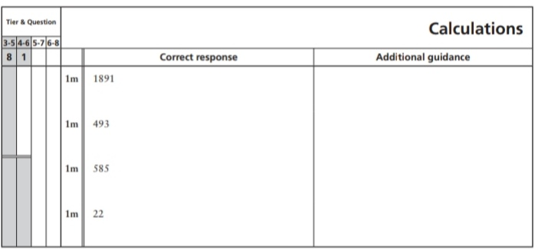
57.
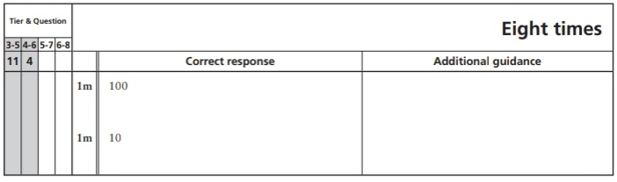
58.
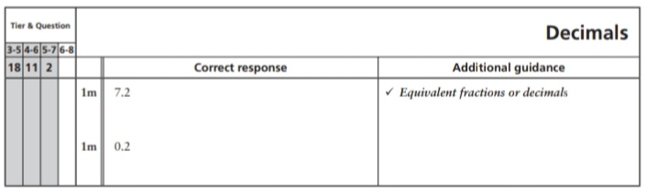
59.
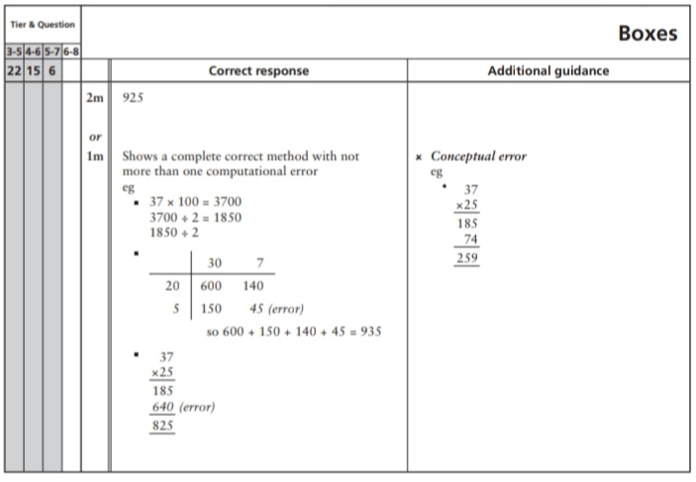
Key Stage 3: 2008 Paper 2 Level 4-6
60.
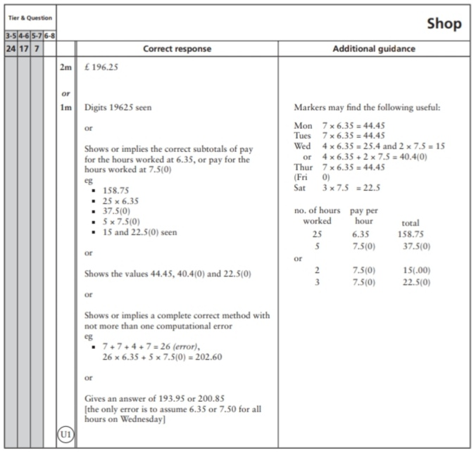
Key Stage 3: 2009 Paper 1 Level 3-5
61.
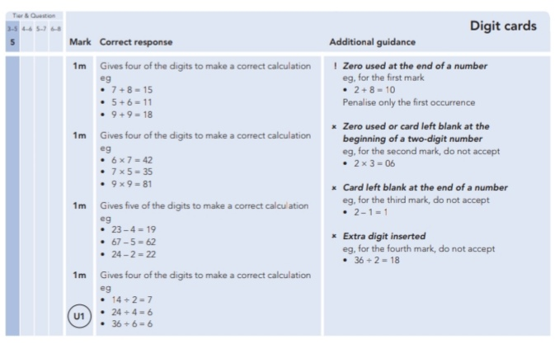
62.
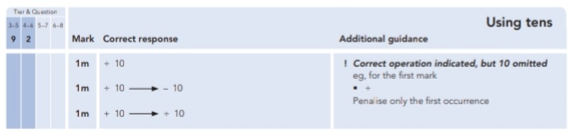
63.
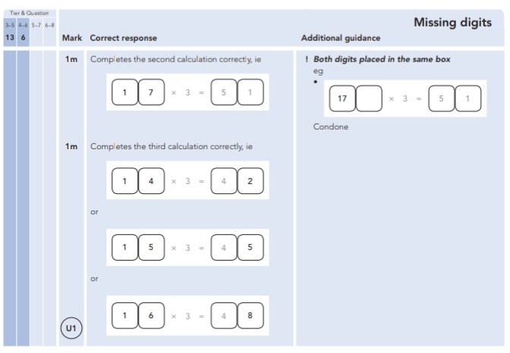
64.
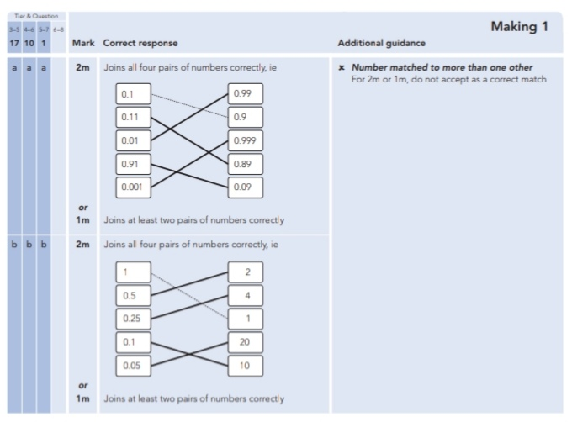
Key Stage 3: 2009 Paper 2 Level 3-5
65.
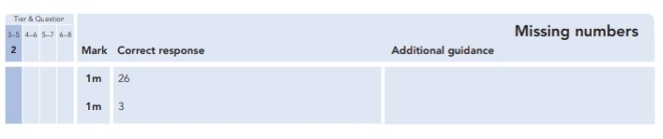
Key Stage 3: 2009 Paper 1 Level 4-6
66.
67.
68.
Key Stage 3: 2009 Paper 2 Level 4-6
69.
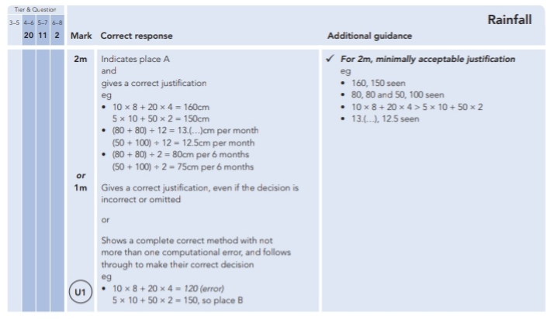
Key Stage 3: 2010 Paper 1 Level 3-5
70.
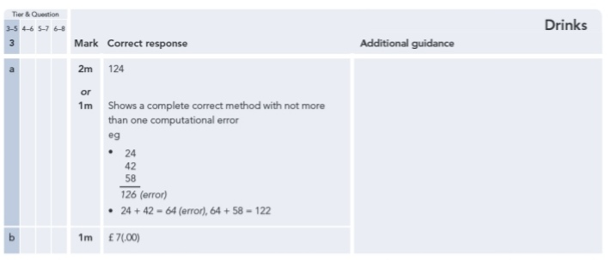
71.
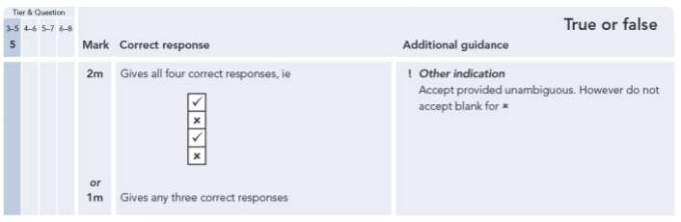
72.
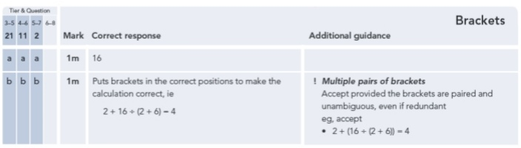
Key Stage 3: 2010 Paper 2 Level 3-5
73.
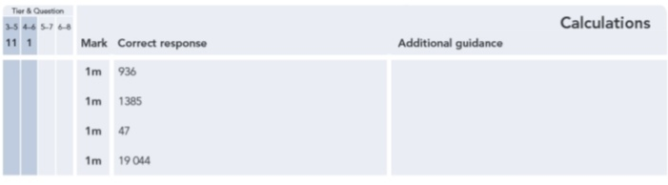
74.
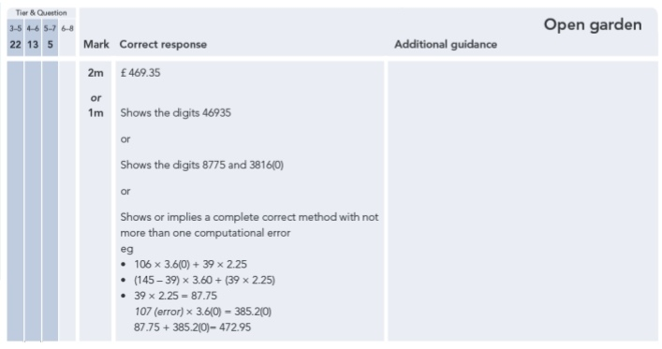
Key Stage 3: 2010 Paper 1 Level 4-6
75.
Key Stage 3: 2010 Paper 2 Level 4-6
76.
77.
Key Stage 3: 2011 Paper 1 Level 4-6
78.
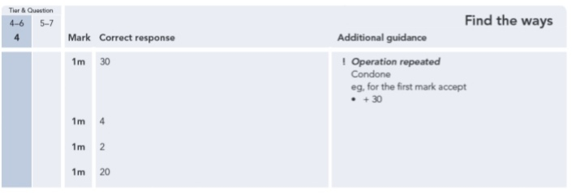
79.
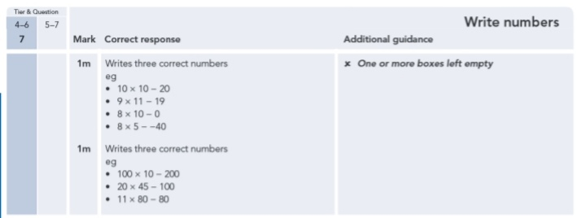
Key Stage 3: 2011 Paper 2 Level 4-6
80.
